Using DeConz ZigBee Rest API for Adjusting Sensitivity of Aqara Vibration Sensor

[Link](https://blog.galt.me/home-assistant-deconz-zigbee-rest-api-usage/) / [Link](https://community.home-assistant.io/t/set-the-sensitivity-for-xiaomi-vibration-sensor-through-rest-api-deconz/95543/26)

Open the 'Plugins' menu and choose 'REST API Plugin'.

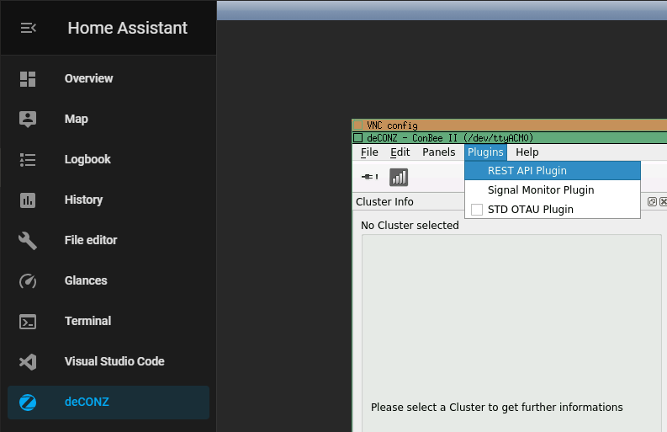

You will now have the address and port for the RESP API.

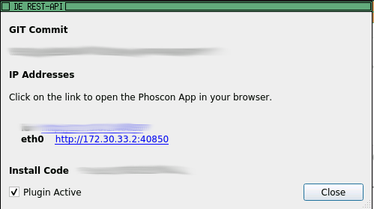

Armed with this info we can now get ourselves setup to use it with a little bit of curl magic. So over to our home assistant terminal now, we are going to type in the following...

(Remember to replace my container IP and port with your own)

**BUT, don't press enter yet!**

curl -X POST -d '{"devicetype": "terminal"}' http://172.30.33.2:40850/api/

With that ready to go, you now need to swap back to deCONZ but go into Phoscon this time.

You need to be in the advanced Gateway settings, like the image below, then click 'Authenticate app'.

Once you have pressed that button you have 60 seconds to swap back to your HA Terminal and hit enter on that command we typed in.

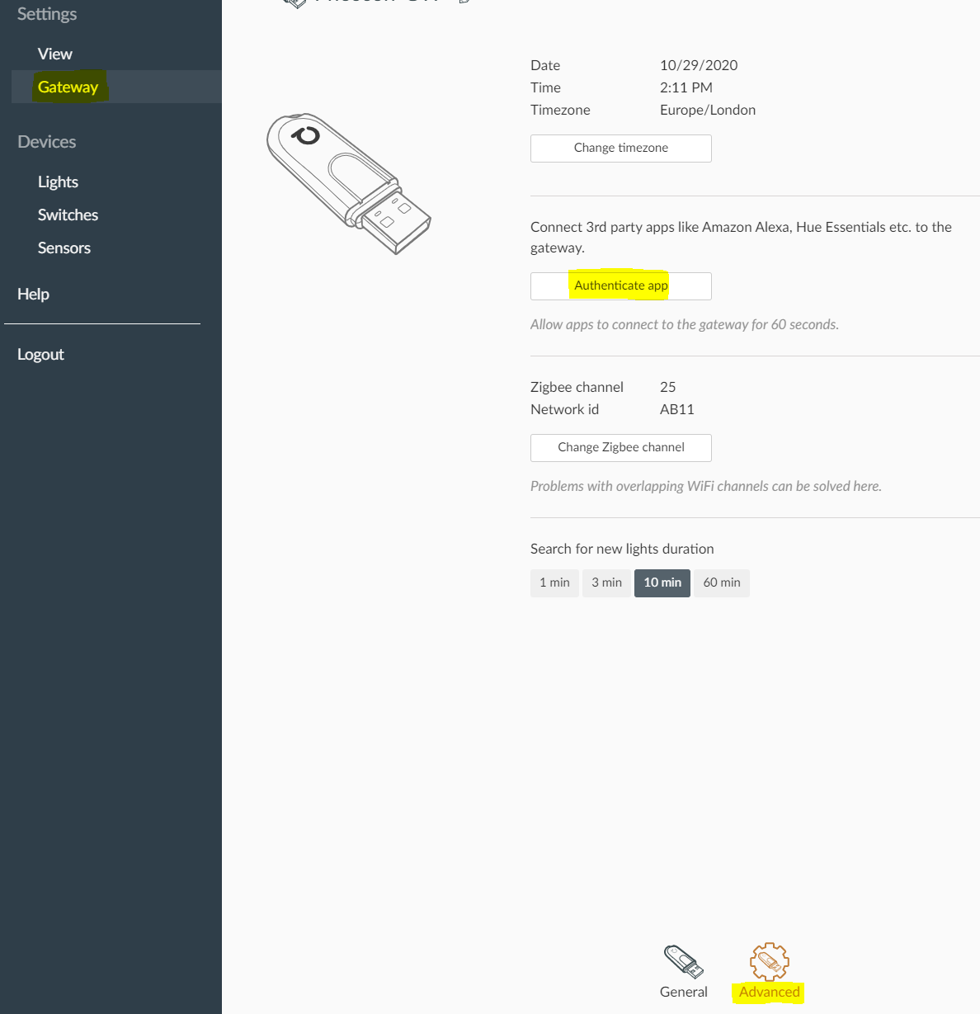

Now your terminal is registered to interact with the API! You will have been given an API key in the returned information. It will be listed as 'username' and then a short string of letters and numbers. Record this as well, since we will need this next. For this example mine is: 9EF25621CD

There is one last piece of information we need to get before we can proceed and that is your entity id.

This is a two digit number that is assigned to your vibration sensor. You can easily find this in Home Assistant by checking Configuration --> Entities and searching for your binary_sensor.vibration entity. This will have a number at the end of the name, in this example mine is called

binary_sensor.vibration_37

So my entity id is 37.

Now we can check this is correct using the API.

The structure looks like this:

http://[ip]:[port]/api/[api-key]/sensors/[sensor id]

So mine looks like this:

curl -X GET http://172.30.33.2:40850/api/FDDA4762E9/sensors/37

Just substitute your values for mine in the appropriate places and you will get back all the information about your vibration sensor, including its current sensitivity value.

At last, it's finally time to change that sensitivity!

curl -H 'Content-Type: application/json' -X PUT -d '{"sensitivity": 1}' http://172.30.33.2:40850/api/FDDA4762E9/sensors/37/config

This will set your sensitivity to the most sensitive value and works well for detecting knocking at the front door or mail coming through the letterbox.

If that's proving too high for your needs, you can continue increasing the value up to a max of 21 for the lowest sensitivity.